1. It is a common practice in machine learning to create synthetic data with well-understood properties to investigate the behavior of an algorithm. Please create your own dataset (at least 10 examples) that is linearly separable. Now train a perceptron model. Provide evidence that your perceptron found a decision boundary. Finally, measure the accuracy of your model on the training set and comment on the result.
   1. 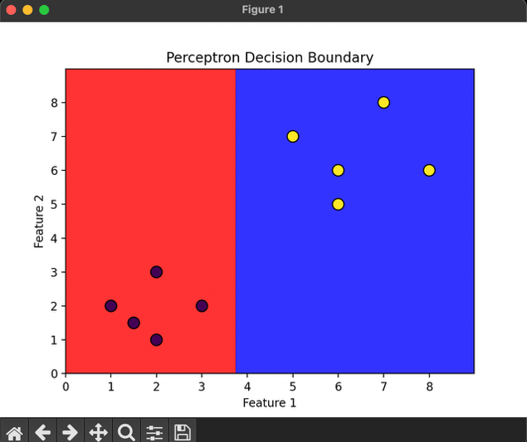
   2. The accuracy measured was 1.0 or 100%. The model was able to correctly linearly separate all points on the graph; the predictions matched the true labels.
2. Create your own small dataset (at least 10 examples) that is not linearly separable. Now train a perceptron model. Did the algorithm converge? Provide evidence. Now measure the accuracy of your model on the training set and comment on the result.
   1. 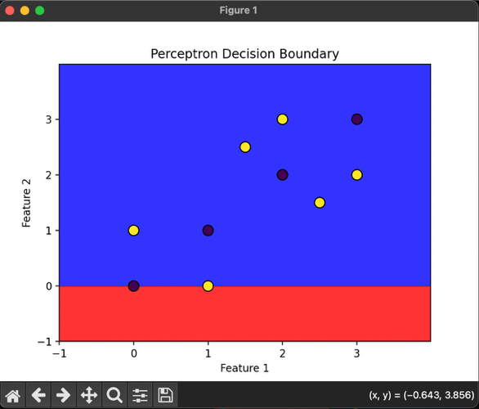
   2. The accuracy measured was 0.6 or 60%. The model was unable to separate all points on the graphs; the predictions did not match the true labels. The program continued to run until manual termination.
3. Download the Titanic dataset and randomly split it into training (70%) and test (30%) sets. Train an Adaline model using the training data. Evaluate it on (a) training data; (b) test data. Is there a difference in performance? Please report your performance and explain the difference